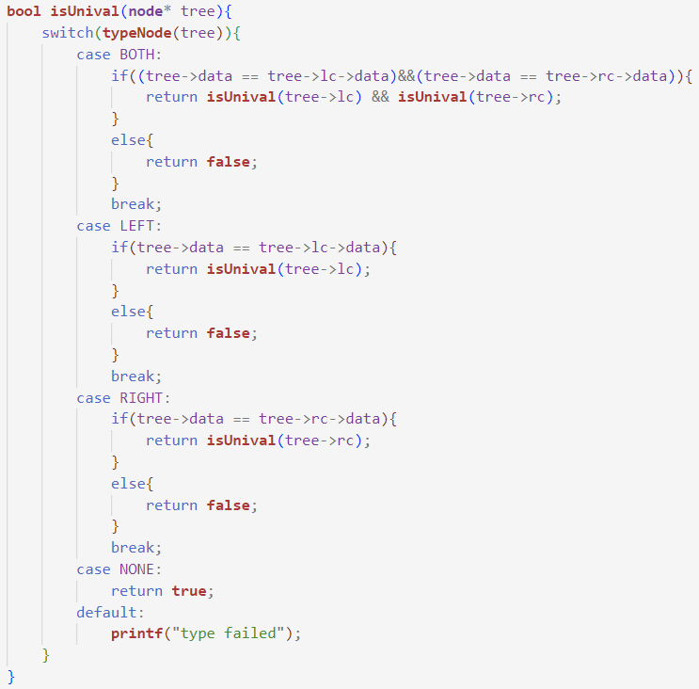

(Fig 1)

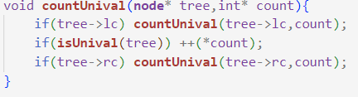

(Fig 2)

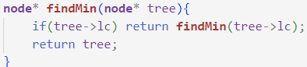

(Fig 1)

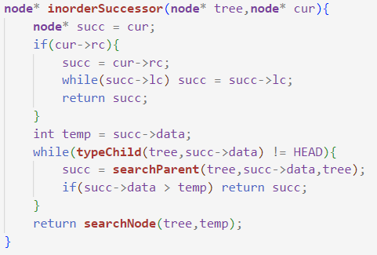

(Fig 2)

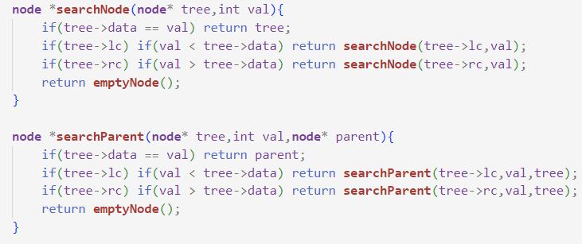

(Fig 3)

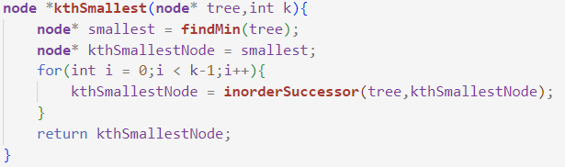

(Fig 4)

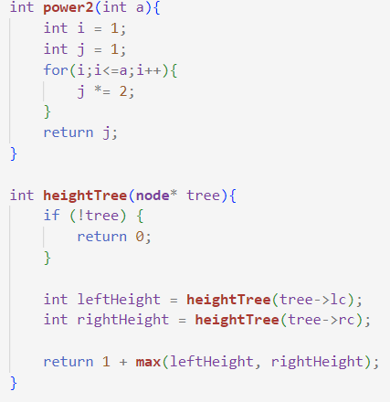

(Fig 1)

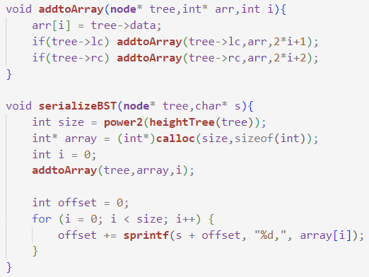

(Fig 2)

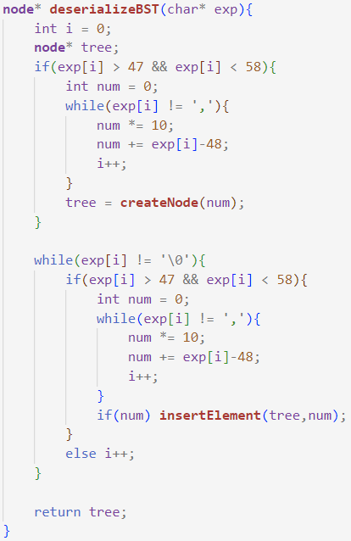

(Fig 3)

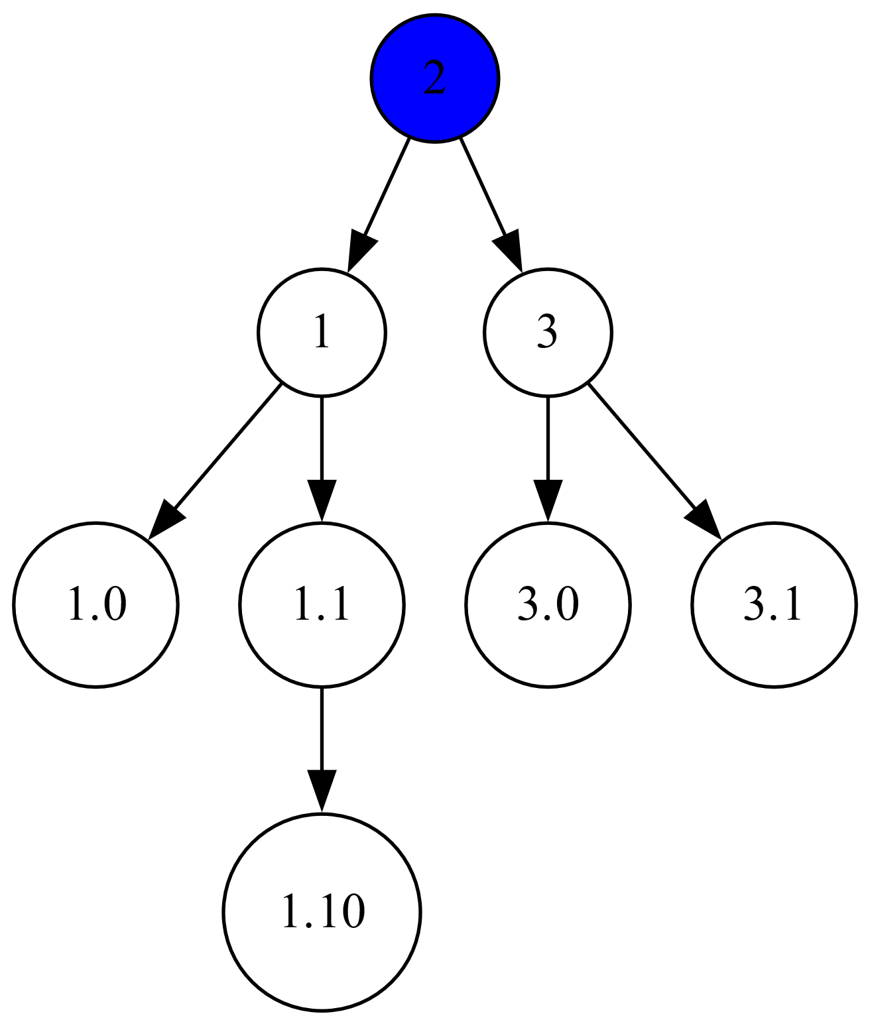

Only consider the whole number sections of nodes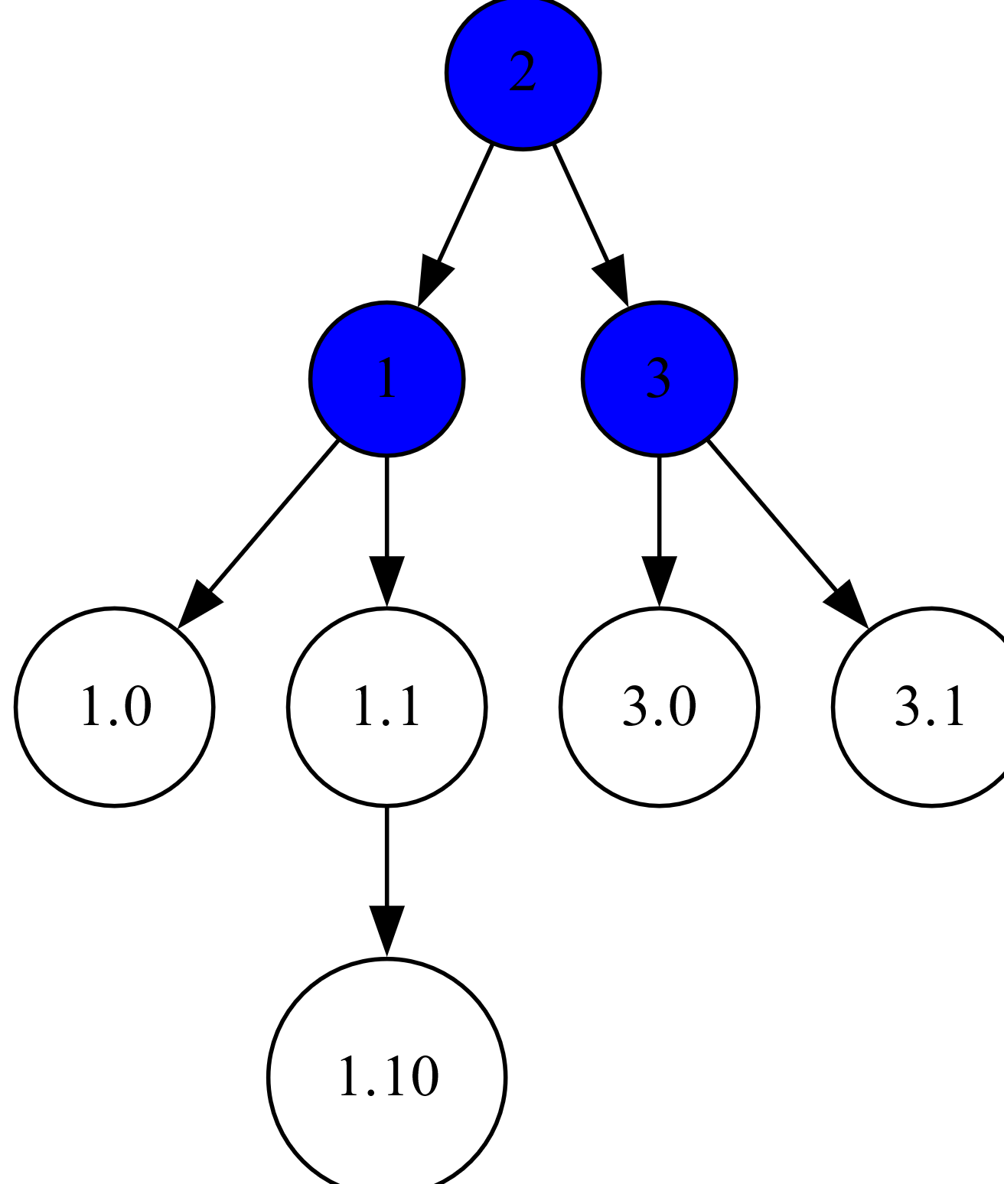

The blue nodes are currently running the isUnival function

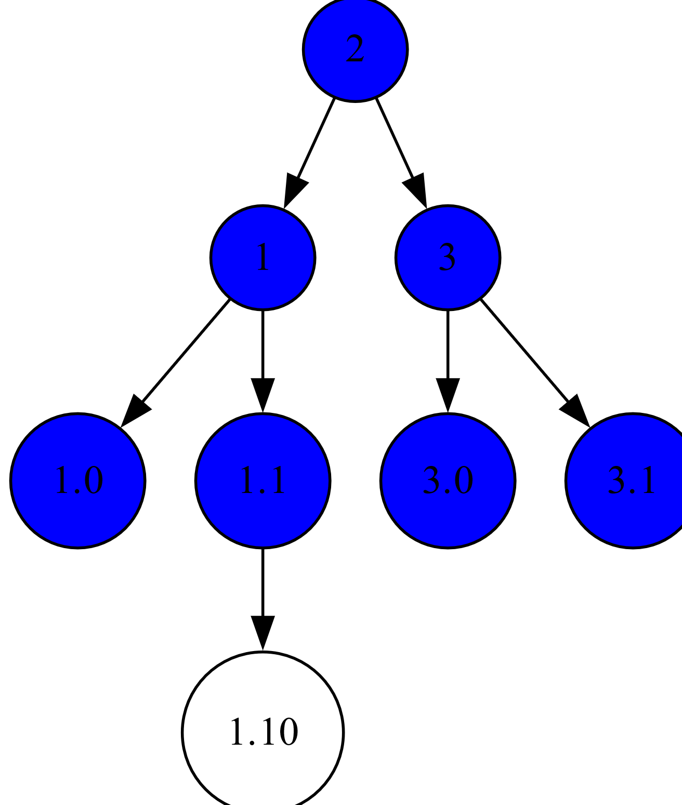

The isUnival function calls the function on every subtree

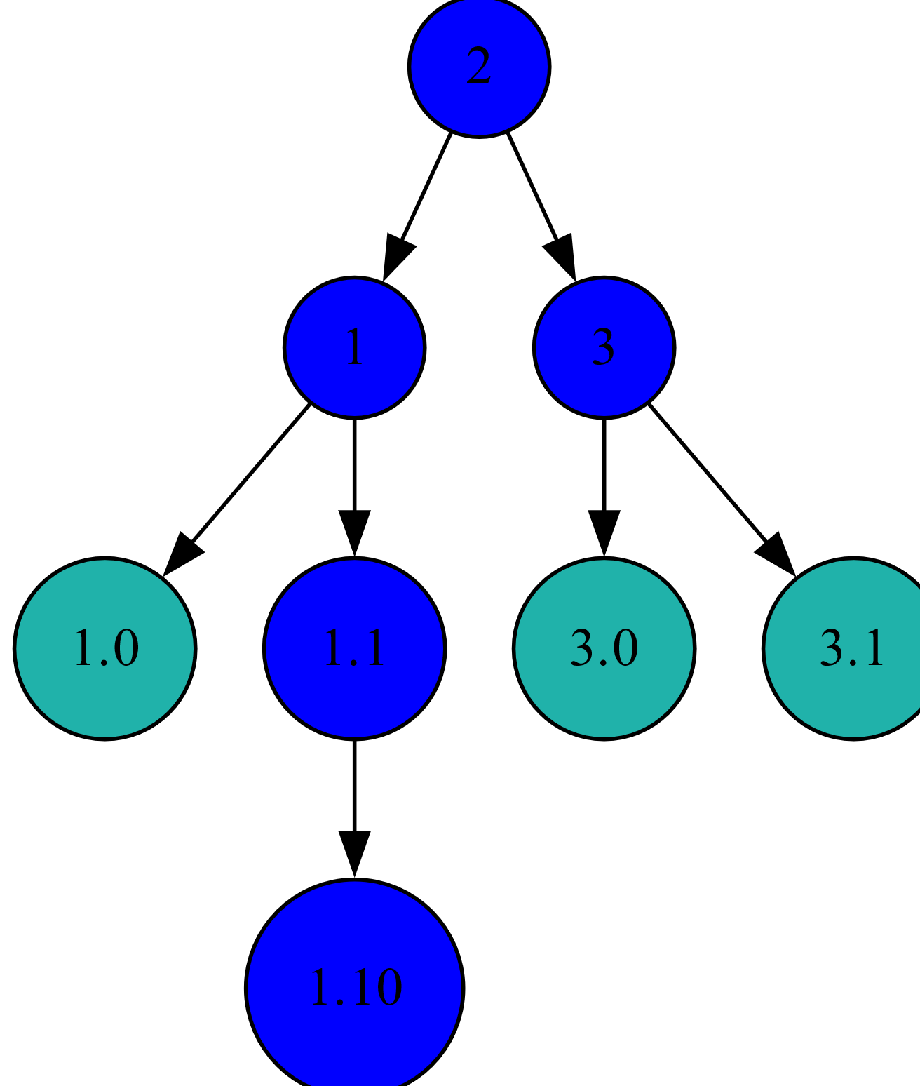

The leaf nodes return a true value

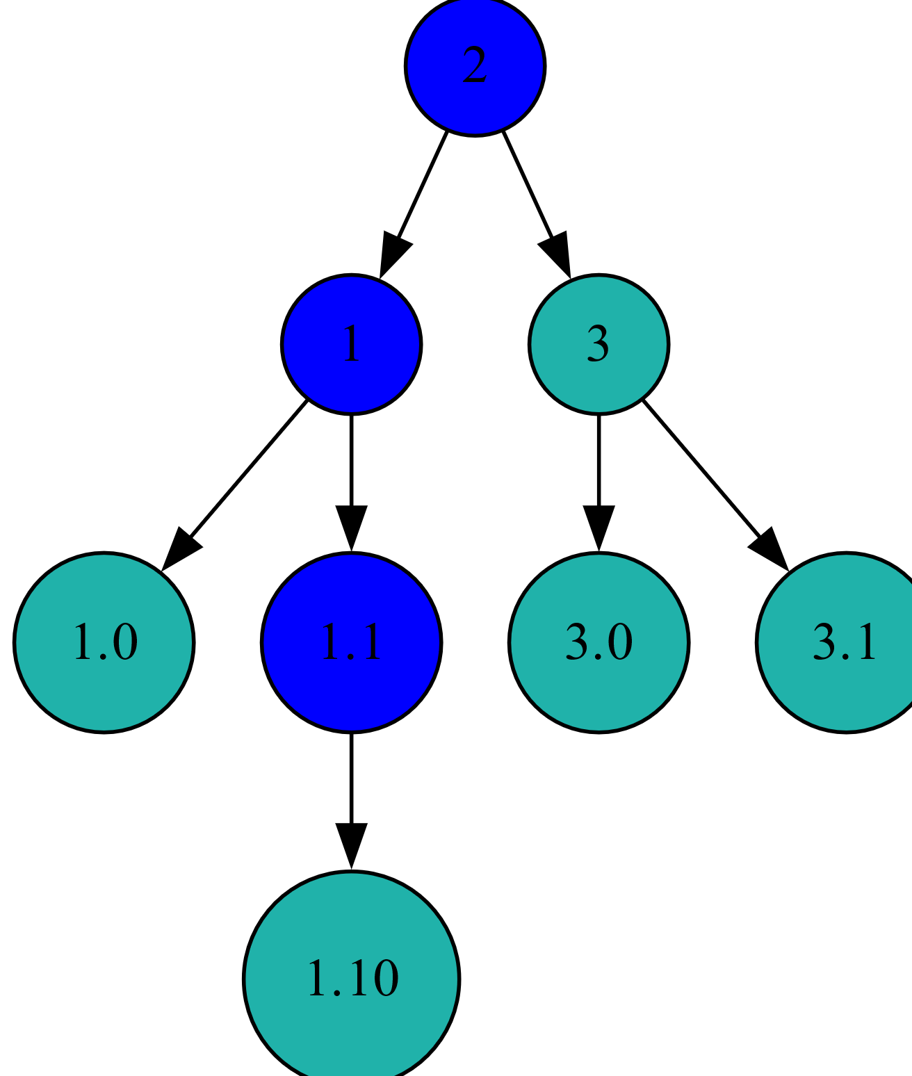

The 3 subtree returns true when its children both return true and are equal to the parent

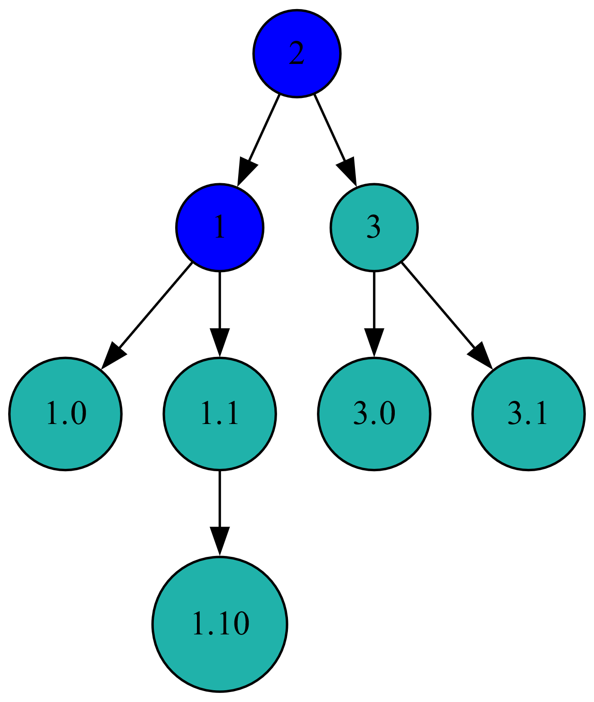

The 1.1 subtree returns true when its only child returns true

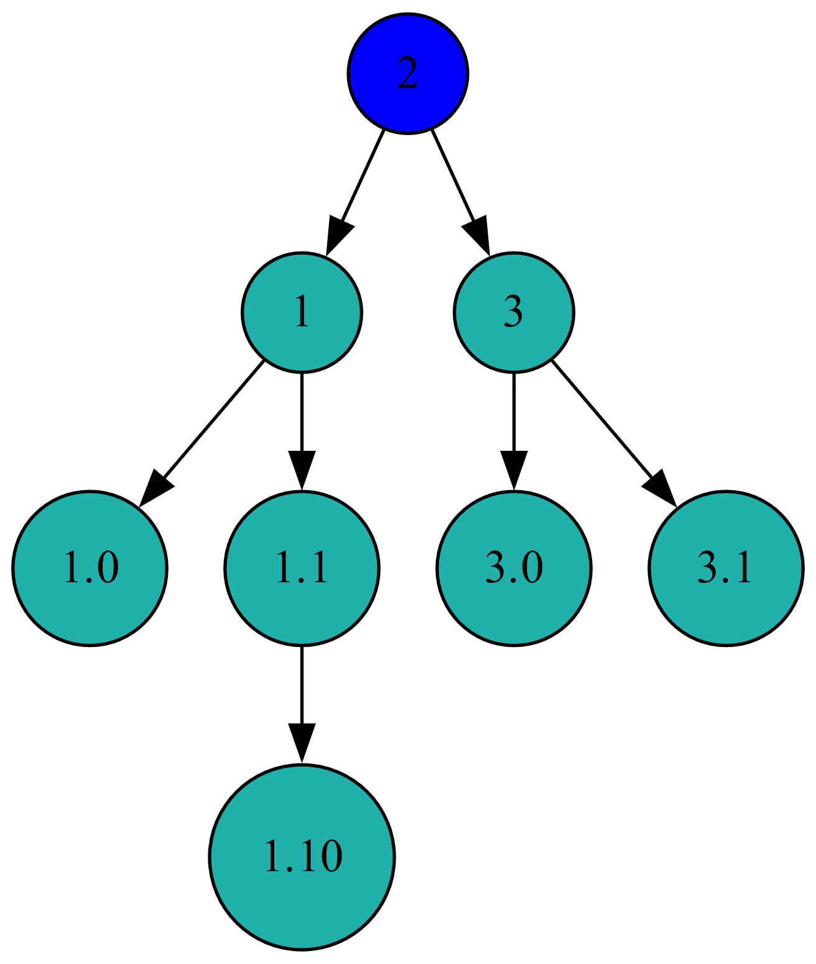

Each node that returns true increments the counter variable

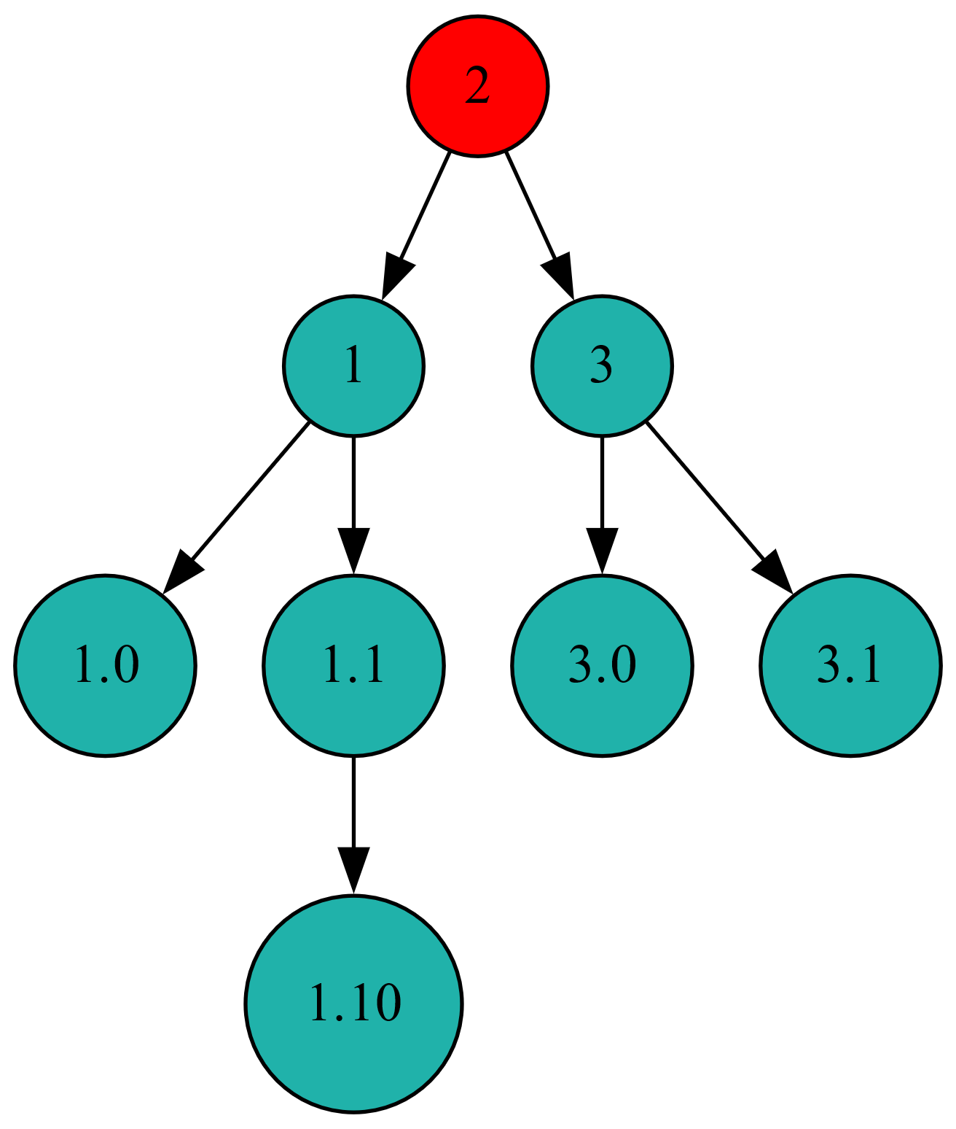

The root node returns false as its not equal to its children, though they returned true

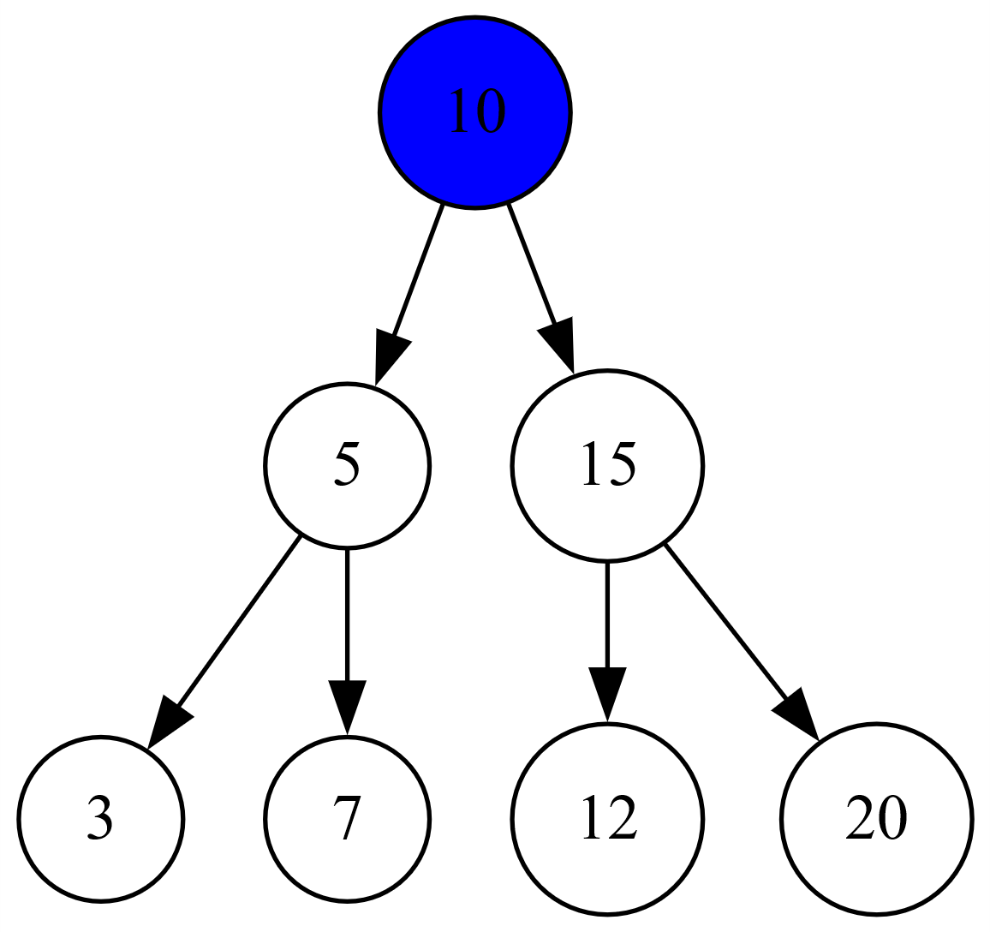

The coloured nodes are running the findMin function

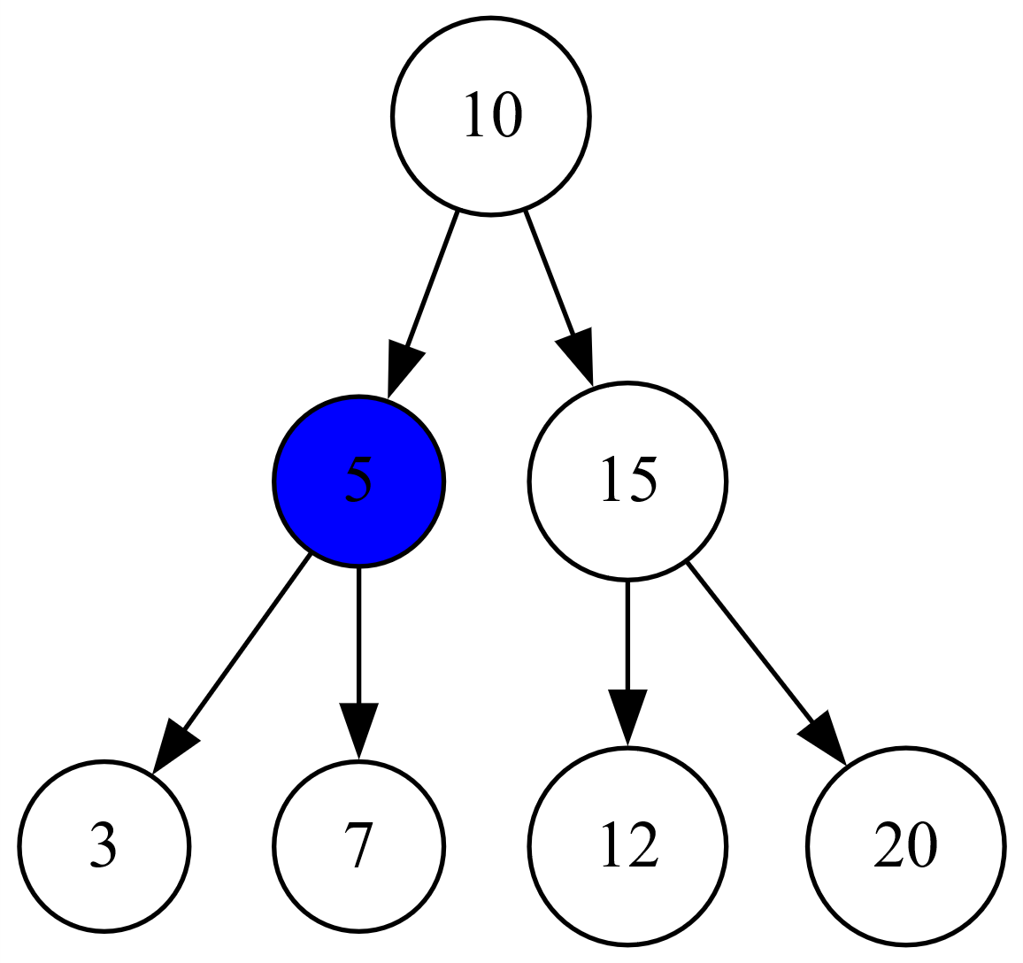

This function simply moves to the left

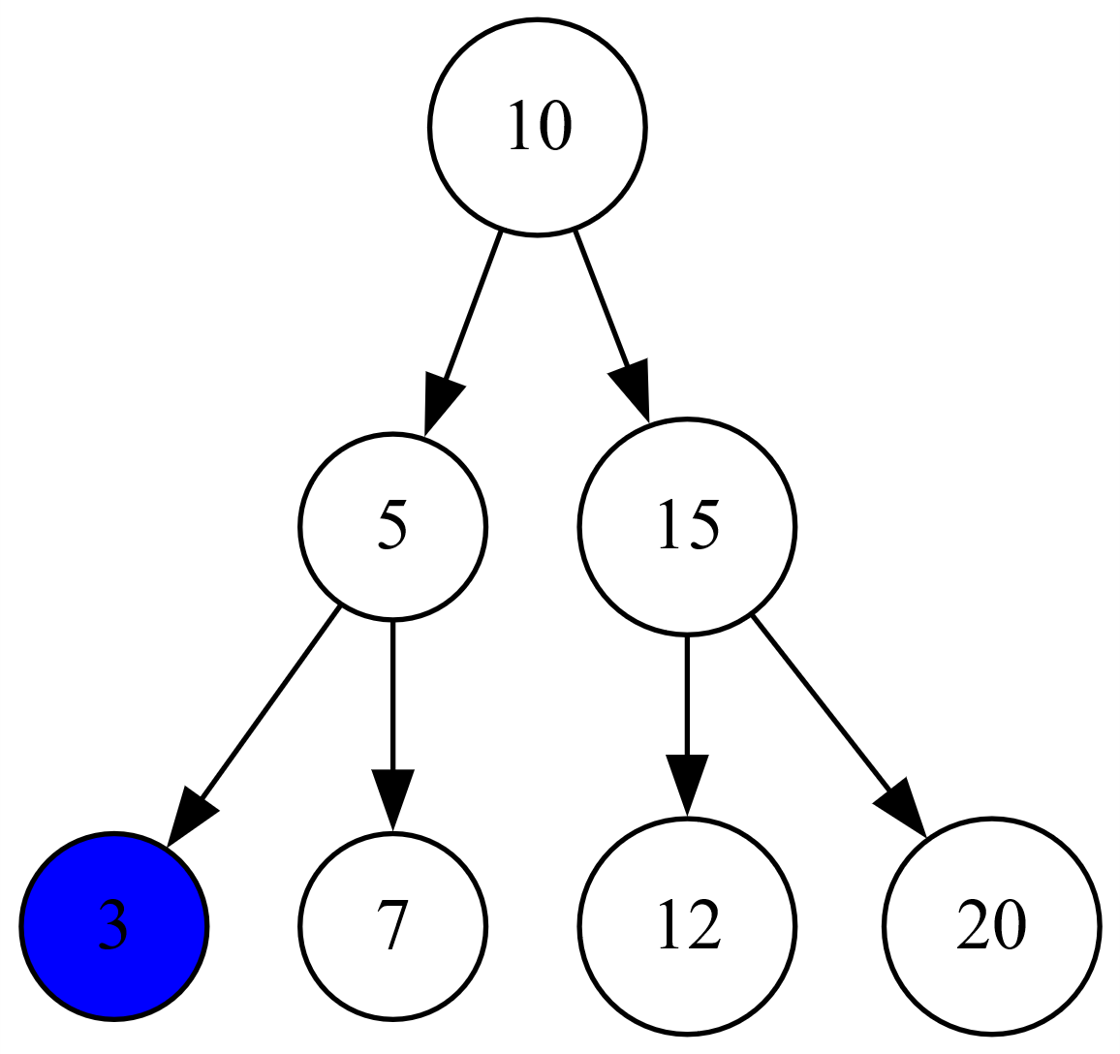

When it reaches a leaf node, it returns it as the smallest node



Here the coloured nodes are the inorder successors of the node in the previous image

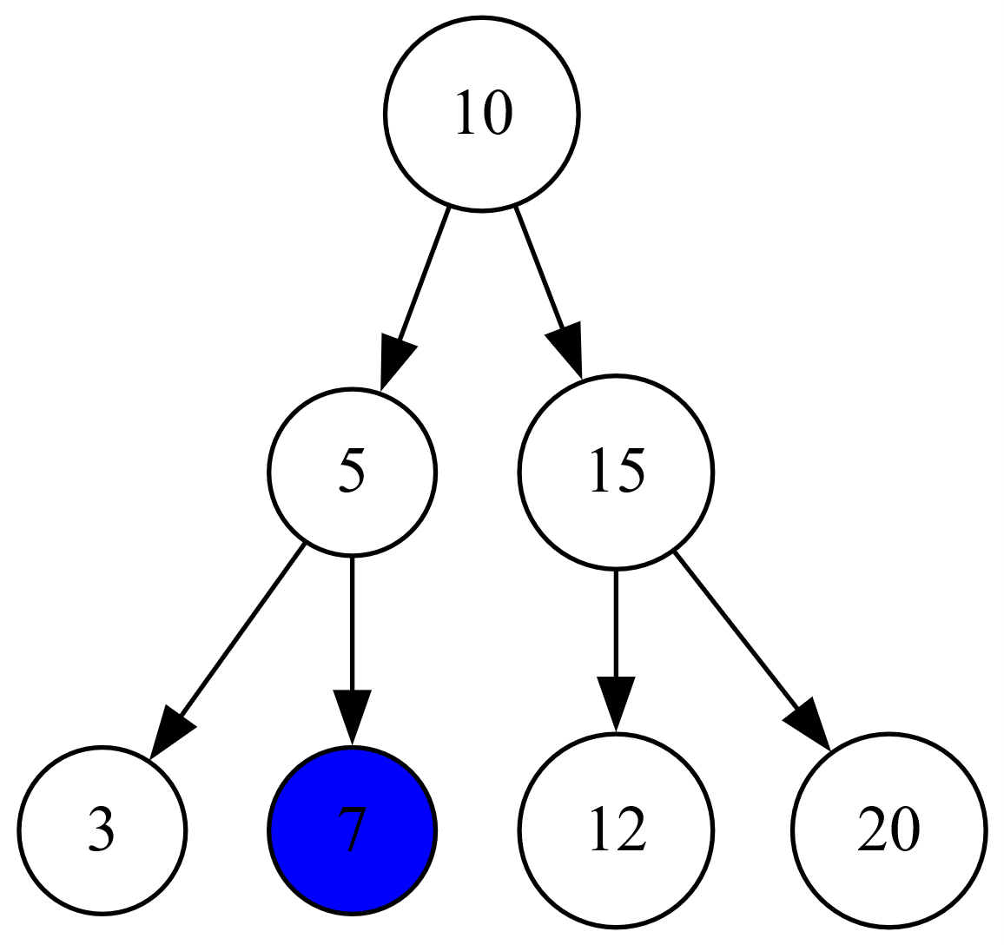

The inorderSuccessor function is called k-1 times(4) and returns that node



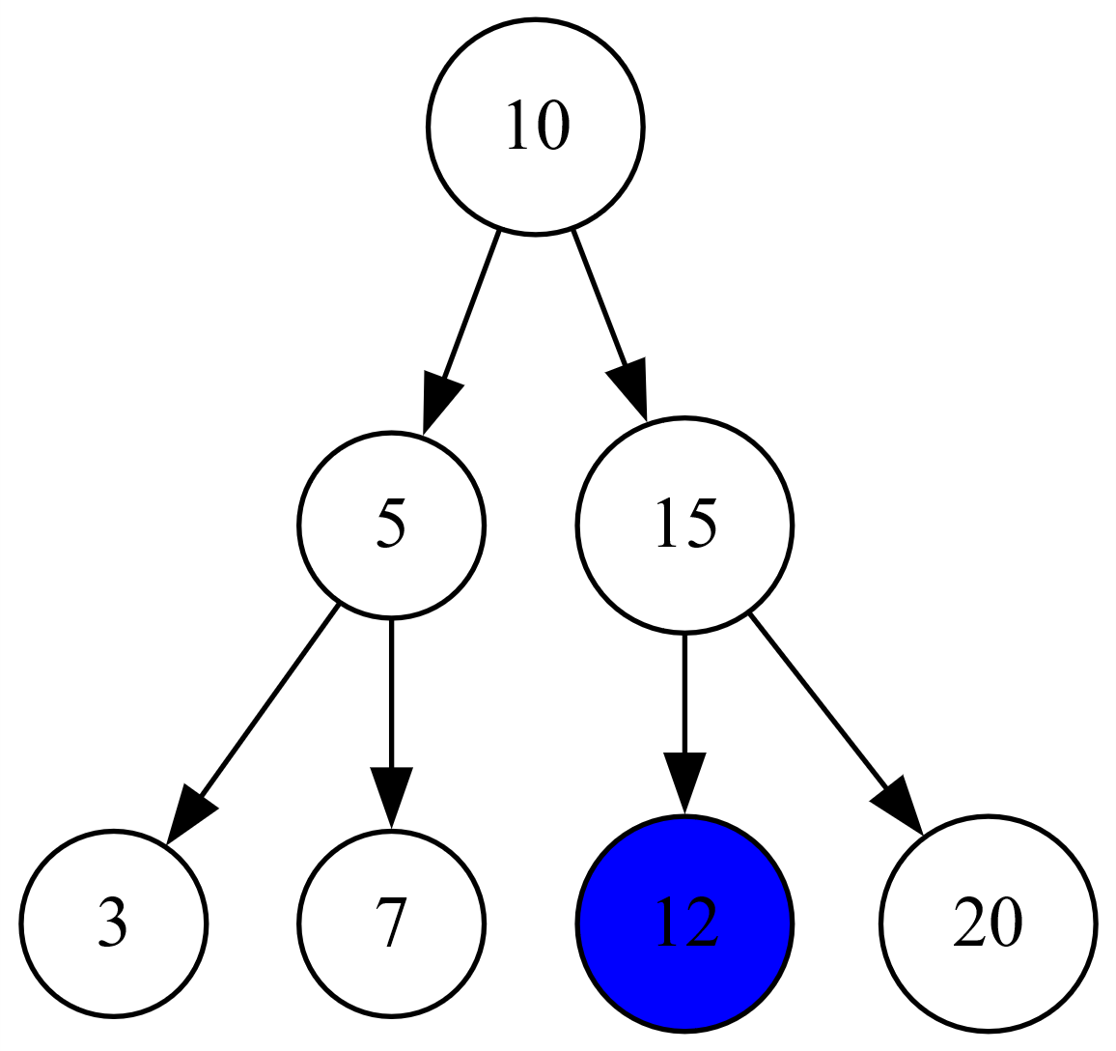

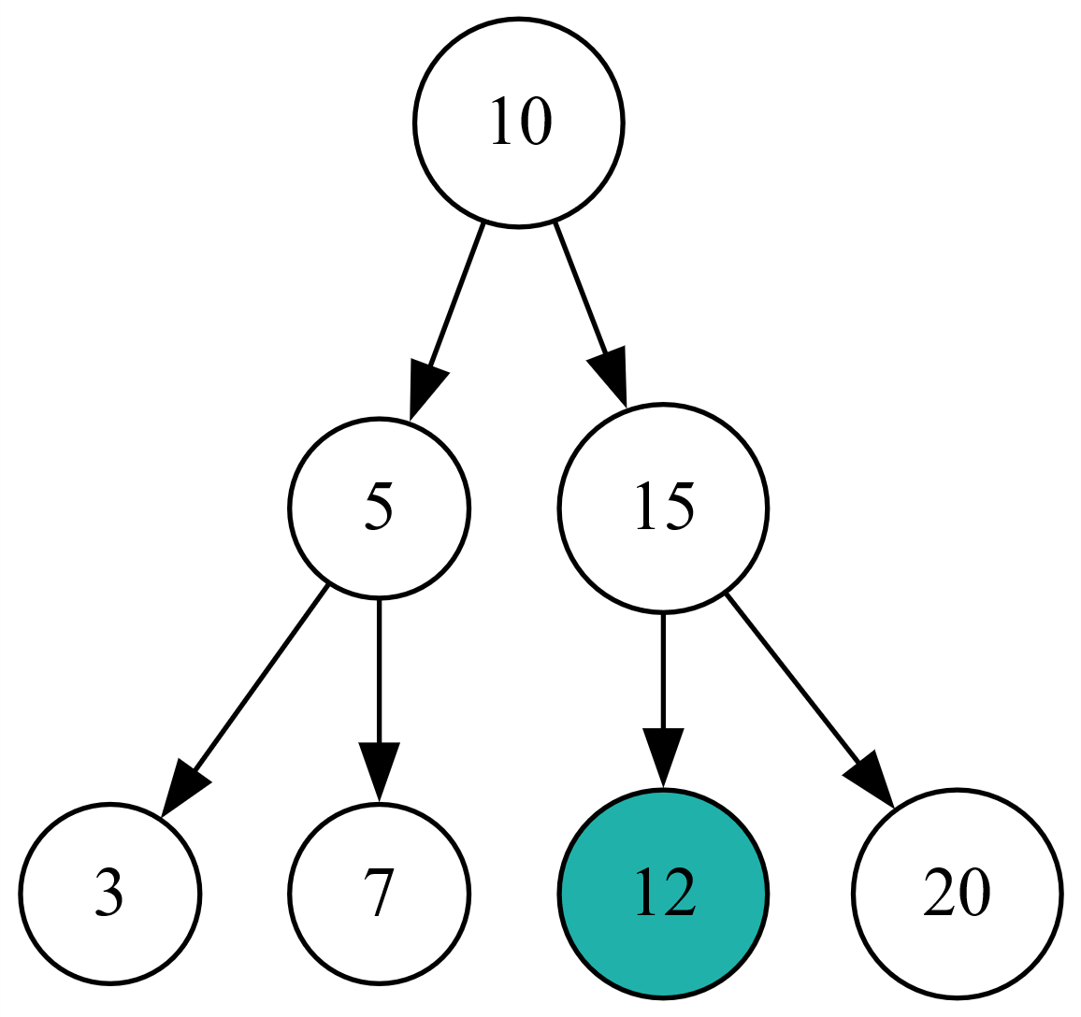

This node is returned

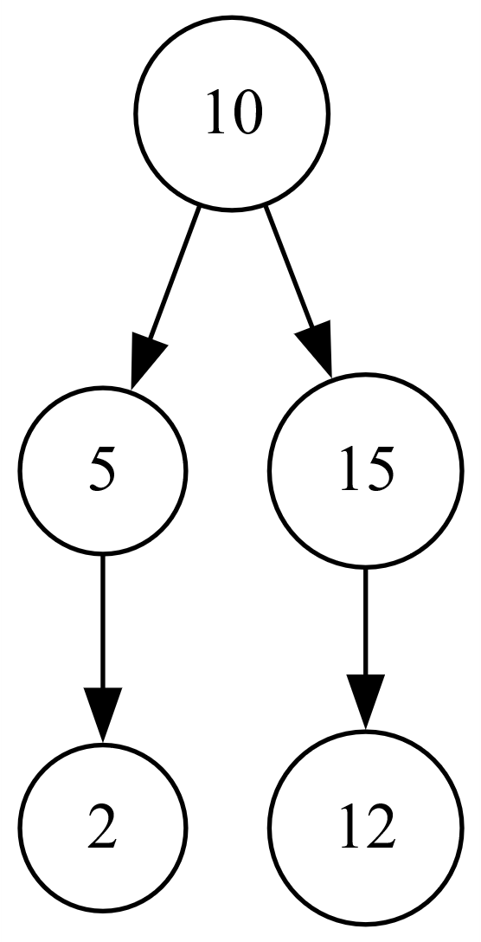

This is the original tree



This is the serialized version with null elements

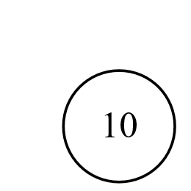

The deserializeBST function first creates a node with the first element

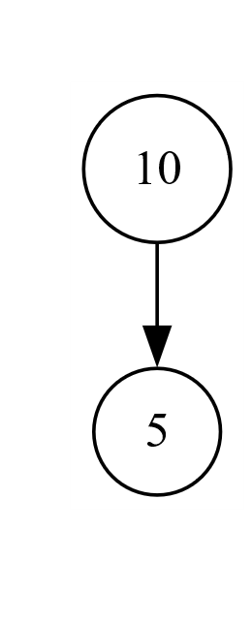

It then iterates through the elements and inserts them into the tree

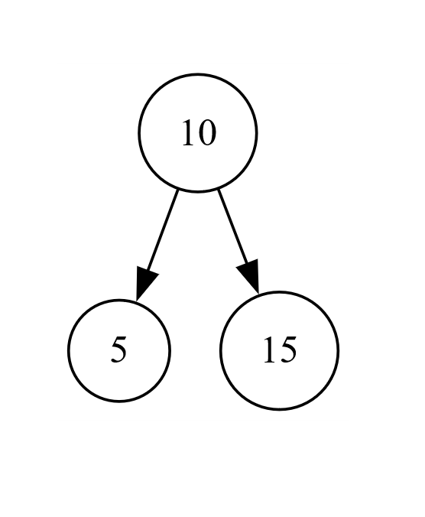

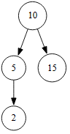

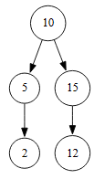

This is the tree returned by the deserializeBST function